LAB SHEET 02

**Sabaragamuwa University of Sri Lanka Faculty of Computing**

**Department of Software Engineering SE6103 – Parallel and Distributed Systems**

# Name : M. S Hewage

Reg. No : 19APSE4300

# Degree Program : Software Engineering Academic Period : 3RD Year 2ND Semester

00

## Task 1: Setting Up the Distributed Hadoop Cluster

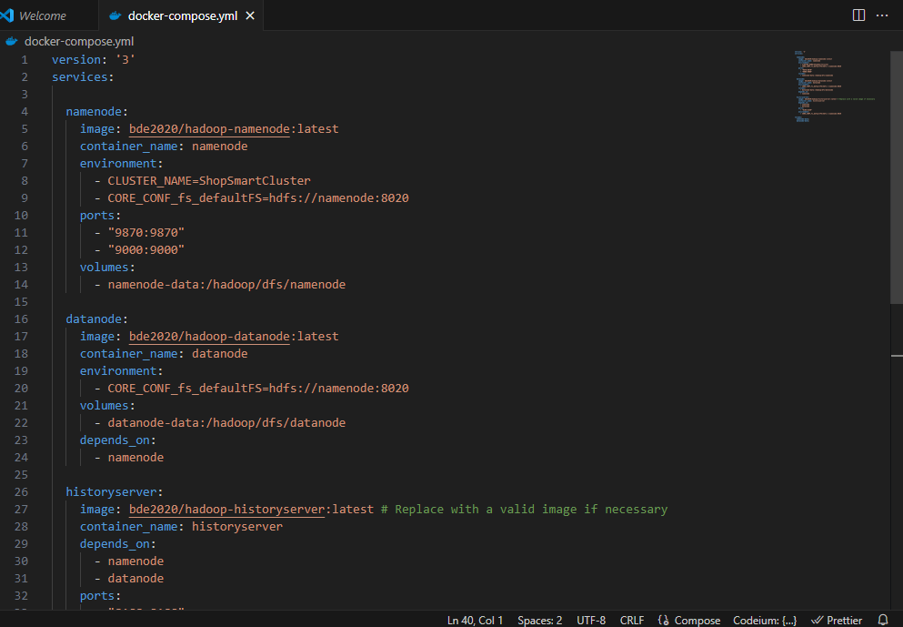Step 1: Prepare the Docker Compose File

Step 2: Deploy the Cluster

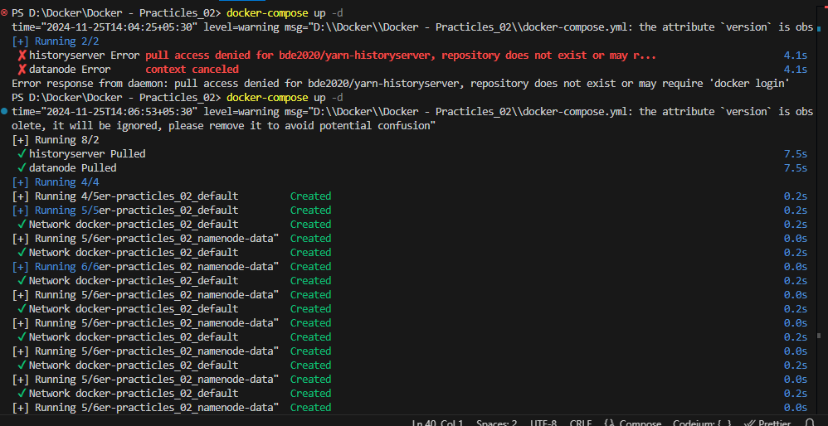

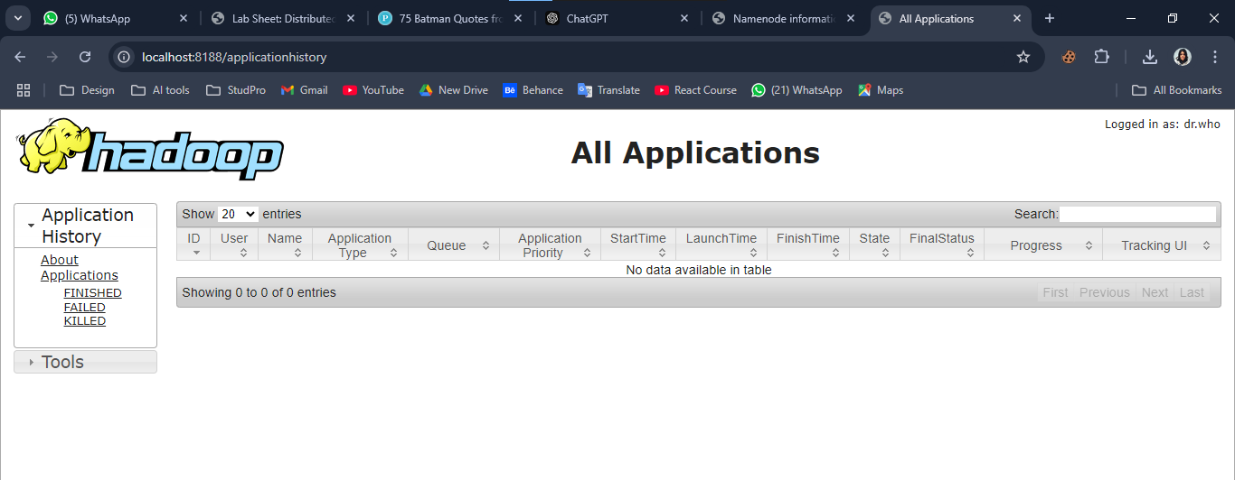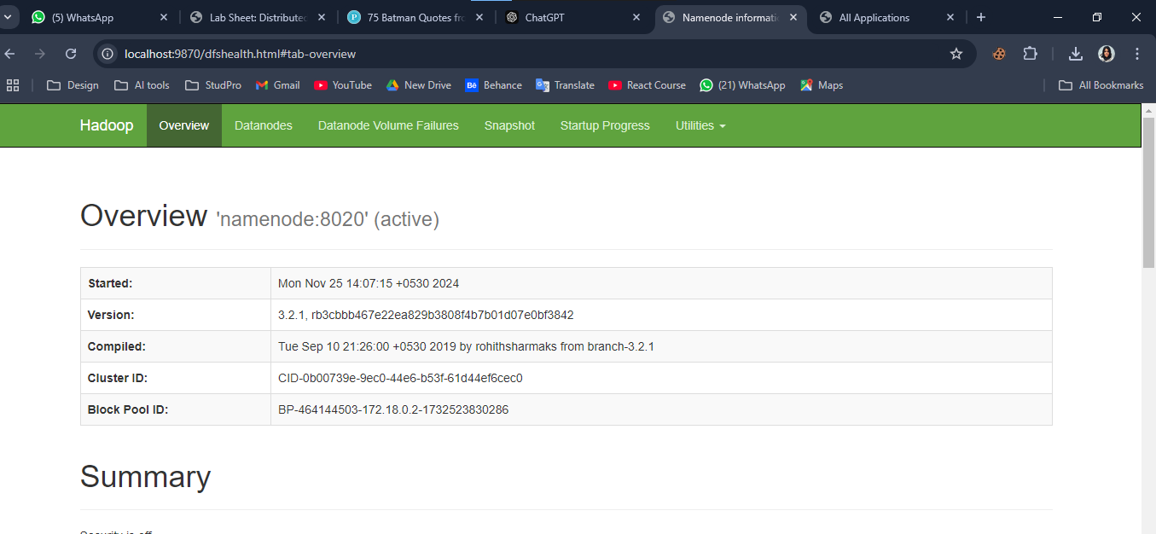4. Step 3: Verify Cluster Status

## Task 2: Uploading Data to HDFS

## 2. Upload Data to HDFS

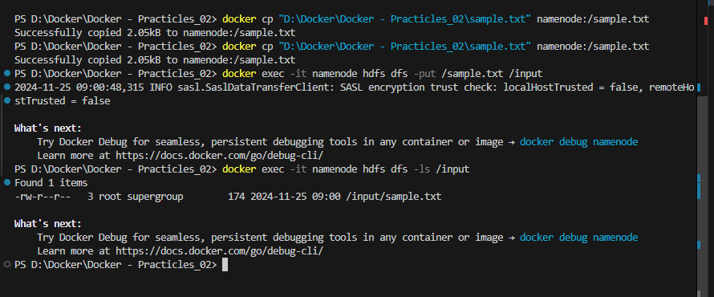

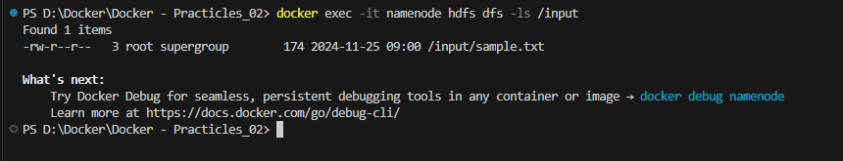

## Task 3: Running a MapReduce Job

## Run the WordCount MapReduce Job

## 

## 2. Monitor the Job

## 

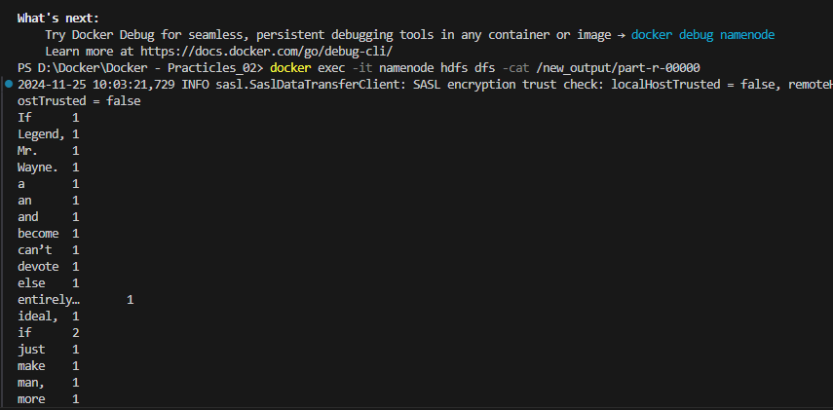

Clean Up the Cluster

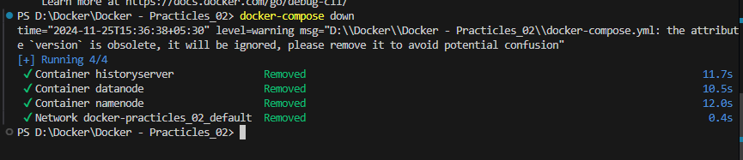

------------------------------------------------------------ EDN ------------------------------------------------------------